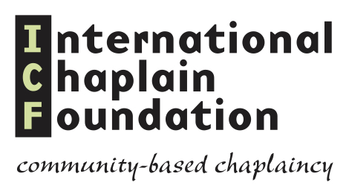

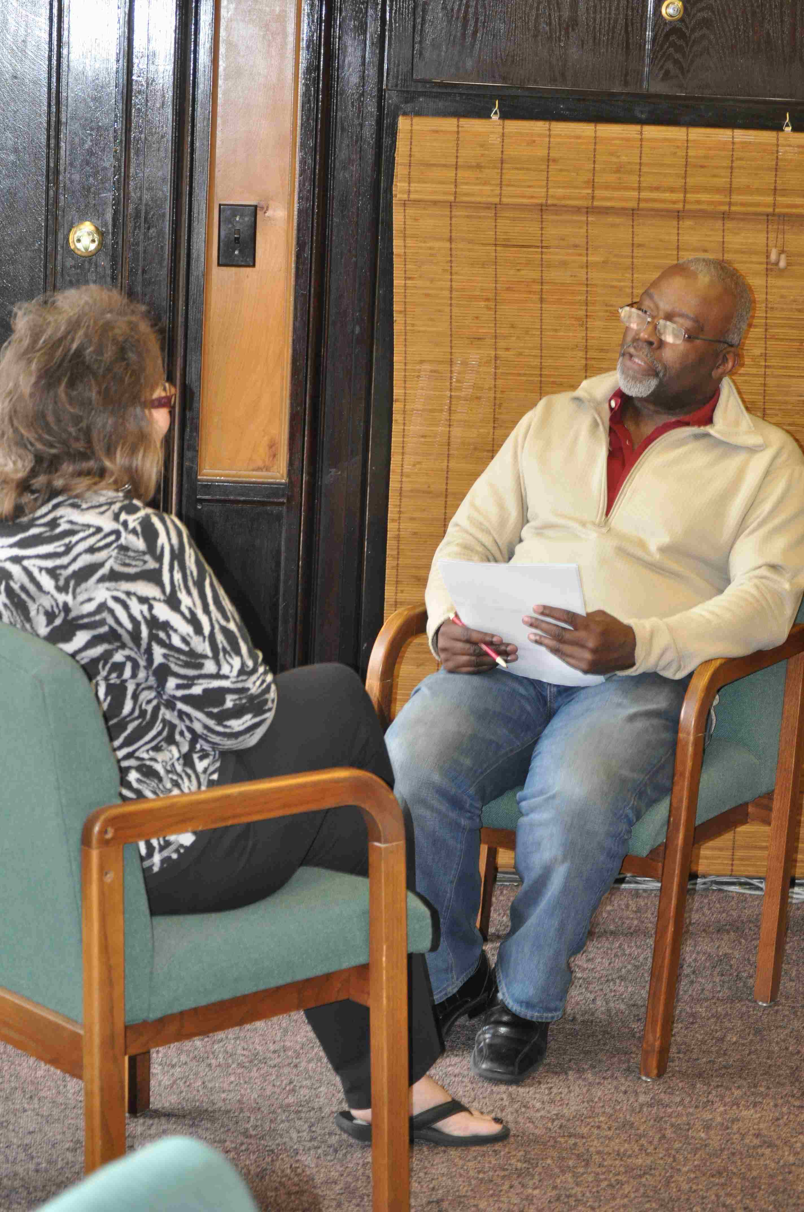

CLINICAL PASTORAL EDUCATION PROGRAM APPLICATION FORM

Extended 26 week Program, Intensive programs

will only be offered for trainees who have at least 1-2

units or on case-by-case consideration.

PLEASE COMPLETE THIS FORM and submit AND SEND THREE COPIES TO:
Rev Andrew Harriott
332 West 47th Street, Suite1B
New York 10036
917.536.0650
rev.andrewharriott54@gmail.com

*All applicants need to be interviewed by the teaching staff, Diplomate Andrew Harriott. Please call or email (rev.andrewharriott54@gmail.com) cell phone number (917.536.0650) ASAP to schedule your interview.

Name:
Address:
City: | State: | ZIP:
Home Phone: | Cell Phone:
Business Phone: | Phone calls at work? Yes No Urgent only
Email address:
In case of emergency, notify:
Relationship: Phone:

CPE Experience - Please list your previous CPE experience, including names of the organizations and the type of pastoral care setting (prison, hospital, church, hospice, etc.):

NOTE: You may attach a resume to this registration form
if it includes the information requested below
Education - Please list your educational degree, area of concentration, school, and year graduated or will graduate (start from the latest):

Skills - Please list any specialized skills, licenses, and/or certifications.

Ordained/Consecrated? No In the future (anticipated date: ) Yes / Year:
Belief system:

Employment
Name of employer (Current or past):
Dates of employment – From: / To:
Job title/Department:
Name of supervisor and contact telephone number:

Please describe why you are interested in doing this training:

Outreach
How did you hear about the CPE Program?
Word of mouth Community presentation Newspaper article Internet
Religious organization Yellow/White pages Flyer. Where seen?
Other? Please specify:

I have truthfully completed this application.

____________________________________________________________________________
Signature Date

References

We need to contact three references before you start. Please provide us the information below or submit a letter from three references (see next page for details.)

Personal Reference #1
Name:
Address:
City: | State: | ZIP:
Email address: | Cell Phone:

Personal Reference #2
Name:
Address:
City: | State: | ZIP:
Email address: | Cell Phone:

Personal Reference #3
Name:
Address:
City: | State: | ZIP:
Email address: | Cell Phone:

CONFIDENTIALITY STATEMENT

I, , realize the importance of observing confidentiality concerning patients, caregivers, and staff. I will not discuss any case or mention any patient's name other than in direct contacts with other members of the CPE training group, and not within hearing distance of anyone outside the team I work with.

Signature Date

With this completed application please send:

- A current autobiography, which should be self-reflective. Please comment on your family origin, significant turning points in your life, and the nature of your religious-spiritual journey at this time in your life.
- An account of an incident in which you were called upon to assist someone in crisis, including your pastoral assessment of the problems, your interventions, and an evaluation of the appropriateness of your help. It is not required that you present a successful example of help.
- A statement of your impressions of Clinical Pastoral Education (CPE) and what you hope to accomplish by participating in it.
- If you have completed any CPE unit, your supervisors evaluation of your performance.
- Three letters of reference from the persons you named above and please advice them to forward the letters to: 332 West 47th Street, Suite 1B, New York 10036 or email to rev.andrewharriott54@gmail.com.
- Should you have any questions about this program and the tuition please contact:
Rev. Andrew Harriott, Diplomate, CC/PC, 332 West 47th Street, Apt. 1B, New York 10036.
Email: rev.andrewharriott54@gmail.com. / Cell 917.536.0650

